DETERMINATION OF THE BLAZE WAVELENGTH

BLAZING AND THE BLAZE CONDITION
It has long been known that diffraction gratings can, in certain configurations, concentrate a large percentage of the energy incident on them into a specific diffraction order. This phenomenon has come to be called blazing.
A grating that is in a configuration in which it is blazing is said to be in the blaze condition. It is important to recognize that it is the characteristics of the grating as well as the conditions under which it is illuminated that contribute to the condition known as blazing.
The measure of the light intensity diffracted from a grating is called its efficiency. The blaze wavelength is defined as that wavelength, in a given diffraction order m, for which the efficiency curve reaches its maximum. Figure 1 shows a typical efficiency curve (diffracted intensity vs. wavelength) with the blaze wavelength noted as λ_{B}.

Figure 1 – A typical efficiency curve: for a given diffraction order, the intensity of light diffracted by the grating varies with wavelength.
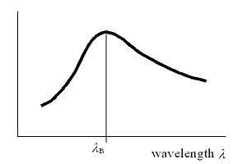

THE BLAZE WAVELENGTH IN THE LITTROW CONFIGURATION
The effect of the groove pattern of a grating on the direction of light diffracted by it is governed by the grating equation,
 | mλ = d(sinα + sinβ) | (1)
where α is the angle of incidence, β the angle of diffraction, λ and m the wavelength and diffraction order, and d the spacing between adjacent grooves on the grating surface.
The Littrow configuration is that specific geometry in which the light of a specific wavelength diffracted from a grating, into a given diffraction order, travels back along the direction of the incident light: in Eq. (1) above, this requires
 | α = β (the Littrow configuration). | (2)
For the Littrow configuration, the grating equation simplifies to
 | mλ = 2dsinα | (3)
Both the general configuration, as given in Eq. (1), and the Littrow configuration are shown in Figure 2.

Figure 2 – (a) The general in-plane diffraction condition. Light of a specific wavelength λ is incident on a grating at an angle α relative to its surface normal GN, and this light is diffracted into a specific order m along an angle β to the surface normal. Both the incident and diffracted rays lie in the plane perpendicular to the groove direction ("in-plane diffraction"). (b) The Littrow configuration. In this case, α = β. Note that in each case, the angles α and β are signed angles (i.e., in (a), α and β have opposite algebraic sign).
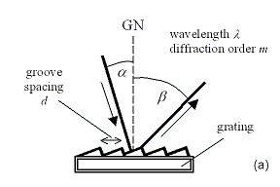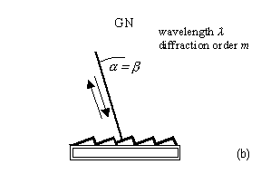

The blaze wavelength in the Littrow condition is that for which the efficiency curve, such as that shown in Figure 1, reaches its maximum when the grating is maintained in the Littrow configuration while the wavelengths are scanned. This requires the grating to rotate to scan wavelength, usually called the monochromator configuration.
The Thermo RGL Diffraction Grating Product Guide indicates the Littrow blaze wavelength (for the first diffraction order, m = 1) for each of its gratings. For ruled gratings (whose grooves are triangular), the blaze wavelength for other orders can be found by the approximation
 | 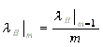 | (4)
namely, the blaze wavelength in order m (Littrow configuration) is approximately equal to the blaze wavelength in the first order, divided by m. For holographic gratings (whose grooves are sinusoidal), Eq. (4) is not valid [see Loewen et al.]
The Littrow blaze angle θ_{B} is defined as the diffraction angle (in the Littrow condition) for the blaze wavelength:
 | mλ_{B} = 2dsinθ_{B} | (5)
THE BLAZE WAVELENGTH FOR OTHER CONFIGURATIONS
When moving off the Littrow condition (i.e., when α ≠ β ), the blaze wavelength and blaze angle generally satisfy the condition
 | mλ_{B} = 2dsinθ_{B}cos(α - θ_{B}) | (6)
That is, the blaze wavelength decreases with the cosine of the angle between the incidence angle α and the Littrow blaze angle θ_{B}. Eq. (6) may be very accurate or an approximation at best, depending on the groove profile and illumination conditions.
EFFICIENCY AT THE BLAZE WAVELENGTH
While it is relatively straightforward, as shown above, to determine the wavelength λ_{B} of maximum efficiency, it is more difficult to determine the maximum efficiency itself. Since this calculation requires the use of Maxwell's equations, it is generally addressed by computer simulation. There are a handful of computer-based grating efficiency programs, some of which are available commercially; Thermo RGL uses PC Grate to simulate the efficiency behavior of its gratings.
REFERENCES
E. G. Loewen, M. Nevière and D. Maystre, "Grating efficiency theory as it applies to blazed and holographic gratings", Applied Optics 16, 2711-2721 (1977).
Erwin G. Loewen and Evgeny Popov, Diffraction Gratings and Applications, Marcel Dekker (New York: 1997).
R. Petit, editor, Electromagnetic Theory of Gratings, volume 22 in Topics in Current Physics, Springer-Verlag (New York: 1980).
Takeshi Namioka, "Diffraction Gratings", chapter 17 in Vacuum Ultraviolet Spectroscopy I, James A. Samson and David L. Ederer, editors; Academic Press (New York, 1998).
Thermo RGL (Richardson Grating Laboratory), Diffraction Grating Handbook (Rochester, New York: 1999).
send me a free copy!

